FARM BUREAU FRESH CITRUS PROGRAM
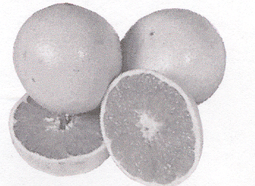
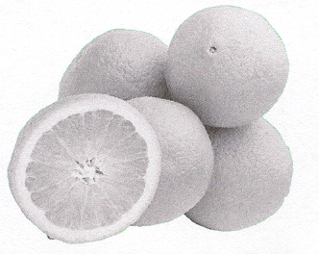

Shelby County Farm Bureau will be offering Fresh Citrus for our members. We will be getting our Grapefruit from Texas and Navels and Clementines from California. The fruit is scheduled to be delivered to the Shelby County Farm Bureau office on December 14th, 2022 at noon. Farm Bureau will not be responsible for fruit quality after one day.

Fill in the order below and return to the Farm Bureau office at 1361 State Highway 128, Shelbyville, IL 62565 to place your order.

PLEASE NOTE DELIVERY DATE WILL BE DECEMBER 14TH at noon to the Shelby County Farm Bureau Office at 1361 State Highway 128, Shelbyville, IL 62565.

ALL ORDERS FOR FRUIT AND NUTS MUST BE PAID FOR IN ADVANCE AND RECEIVED BY NOVEMBER 16, 2022.

FARM BUREAU FRUIT AND NUT PROGRAM - 2022
"A FARM BUREAU MEMBERSHIP PROGRAM"
PLEASE ORDER QTY |  |  | TOTALS
CITRUS
___ | 20 lb. box Navel Oranges | $25.00/ea | $_______.__
___ | 40 lb. box Navel Oranges | $42.00/ea | $_______.__
___ | 20 lb. box Red Grapefruit | $20.00/ea | $_______.__
___ | 40 lb. box Red Grapefrut | $36.00/ea | $_______.__
___ | 20 lb. Premium Holiday Fruit Box  (Contains: Washington Apples, Oranges, Grapefruit, Pears, Clementines, Lemons, Limes, Pineapple, Gourmet Popcorn Kernels & Cheese Curds) | $35.00/ea | $_______.__
___ | 20 lb. box Clementines | $38.00/ea | $_______.__
NEW CROP
___ | 1 lb. Bag(s) Shelled Pecan Halves | $10.50/ea | $_______.__
___ | 1 lb. Bag(s) Pecan Pieces | $10.00/ea | $_______.__
ASSORTED CANDIES AND NUTS
___ | 1 lb. Bag(s) Light Walnuts | $12.25/ea | $_______.__
___ | 1 lb. Bag(s) Mixed Nuts (no peanuts) | $12.25/ea | $_______.__
___ | 1 lb. Bag(s) Giant Whole Cashews | $12.25/ea | $_______.__
___ | 1 lb. Honey Roasted Peanuts | $9.00/ea | $_______.__
___ | 1 lb. Chocolate Covered Pecans | $12.00/ea | $_______.__
___ | 1 lb. Chocolate Covered Peanuts | $10.00/ea | $_______.__
___ | 9 oz. Milk Chocolate Pecan Clusters | $11.00/ea | $_______.__
___ | 1 lb. Bag(s) Milk Chocolate Raisins | $9.00/ea | $_______.__

TOTAL REMITTED WITH ORDER $_______.__

Make Checks payable to: Shelby County Farm Bureau

NAME:_________________________________ PHONE:________________
E-MAIL: _______________________________________________________

